**Motivate Audience to Respond to Your Persuasive Message**

1. **Use cognitive dissonance**

Telling listeners about existing problems or information that **is inconsistent with their currently held beliefs** or **known information** creates **psychological discomfort.**

**Dissonance theory** is based on the principle that people strive to solve problems and manage stress and tension in a way that is consistent with their attitudes, beliefs, and values. According to this theory, when you are presented with information inconsistent with your current attitudes, beliefs, values, or behavior, you become aware that you have a problem; you experience a kind of discomfort called **cognitive dissonance**. Creating dissonance with a persuasive speech can be an effective way to change attitudes and behavior. **The first tactic in such a speech is to identify an existing problem or need.**

In using dissonance theory to persuade, speakers have an **ethical responsibility** not to rely on false claims to create dissonance. Claiming that a problem exists when it does not or creating dissonance about a problem that is unlikely to happen is unethical. When listening to a persuasive message, pay particular attention to the evidence a speaker uses to convince you that **a problem really does exist**.

e.g. Do you value your family’s security? Then you’re probably worried about **supporting your family if you were injured and couldn’t work**. You can restore your peace of mind by buying our disability insurance policy.(a real problem)

e.g. You smoke cigarettes and a speaker reminds you that smoking is unhealthy, this reminder creates dissonance. You can restore balance and solve the problem either by no longer smoking or by rejecting the message that smoking is harmful.

**How Listeners cope with Dissonance**

Effective persuasion requires more than simply creating dissonance and then suggesting a solution. When your listeners confront dissonant information, various options are available to them besides following your suggestions. You need to be aware of the other ways your audience might react before you can reduce their cognitive dissonance.

●Listeners may **discredit the source.** Instead of believing everything you say, your listeners could **choose to discredit you.** Suppose you drive a Japanese-made car and you hear a speaker whose father owns a Chevrolet dealership advocate that all Americans should drive cars made in the United States. You could agree with him, or you could decide that the speaker is biased because of his father’s occupation. Instead of selling your Japanese-made car and buying an American one, you could doubt the speaker’s credibility and ignore his suggestion. **As a persuasive speaker, you need to ensure** that your audience will **perceive you as competent and trustworthy** so that they will accept your message.

●Listeners may **reinterpret the message.** A second way your listeners might overcome cognitive dissonance and restore balance is to **hear what they want to hear.** They may choose to focus on the parts of your message that are consistent with what they already believe and **ignore the unfamiliar or controversial parts.** If you tell a customer looking to purchase new software that it takes ten steps to install the program but that it is easy to use, the customer might focus on those first ten steps and decide it’s too hard to use. Your job as an effective speaker is to make your message as clear as possible so your audience will not reinterpret it. In this case, your task is to emphasize that the software is easy to use. Choose your words carefully; use simple, vivid examples to **keep listeners focused on what’s most important.**

●Listeners may **seek new information**. Another way that listeners cope with cognitive dissonance is to seek more information on the subject. Audience members may look for additional information to negate your position and to refute your well-created arguments. For example, as the owner of a minivan, you would experience dissonance if you heard a speaker describe a recent rash of safety problems with minivans. You might turn to a friend and whisper, “Is this true? Are minivans really dangerous? I’ve always thought they were safe.” You would **want new information to validate your ownership of a minivan**.

●Listeners may **stop listening**. Some messages are so much at odds with listeners’ attitudes, beliefs, and values that an audience may decide to stop listening. Most of us do not seek opportunities to hear or read messages that oppose our opinions. It is unlikely that a staunch Democrat would attend a fund-raiser for the state Republican party. The **principle of selective exposure** suggests that we tend to pay attention to messages that are consistent with our points of view and to avoid those that are not. When we do find ourselves trapped in a situation in which we must hear a message that doesn’t support our beliefs, we tend to stop listening. **Being aware of your audience’s existing attitudes, beliefs, and values can help ensure that they won’t tune you out.**

●Listeners may **change their attitudes, beliefs, values, or behavior.** A fifth way an audience may respond to dissonant information is to **do what the speaker wants them to do.** As we have noted, if listeners change their attitudes, they will reduce the dissonance they experience. You listen to a life-insurance salesperson tell you that your family will have no financial support when you die. This creates dissonance; you prefer to think of your family as happy and secure. So you take out a $250,000 policy to protect your family. This action restores your sense of balance. The salesperson has persuaded you successfully. The goals of advertising copywriters, salespeople, and political candidates are similar: **They want you to experience dissonance so that you will change your attitudes, beliefs, values, or behavior.**

1. **Use Listener’s needs:**

People are motivated by unmet needs. The most basic needs are physiological, followed by safety needs, social needs, self-esteem needs, and finally, self-actualization needs.

e.g. You could be the envy of people you know if you purchase this sleek new sports car. You will be perceived as a person of high status in your community.

Need is one of the best motivators. A person looking at a new car because he or she needs one is more likely to buy than a person who is just thinking about how nice it would be to drive the latest model. **The more you understand what your listeners need, the greater the chances are that you can gain and hold their attention and ultimately get them to do what you want**. Abraham Maslow’s classic theory, which you may have first learned about in psychology class, suggests that there is a hierarchy of needs that motivates everyone’s behavior.

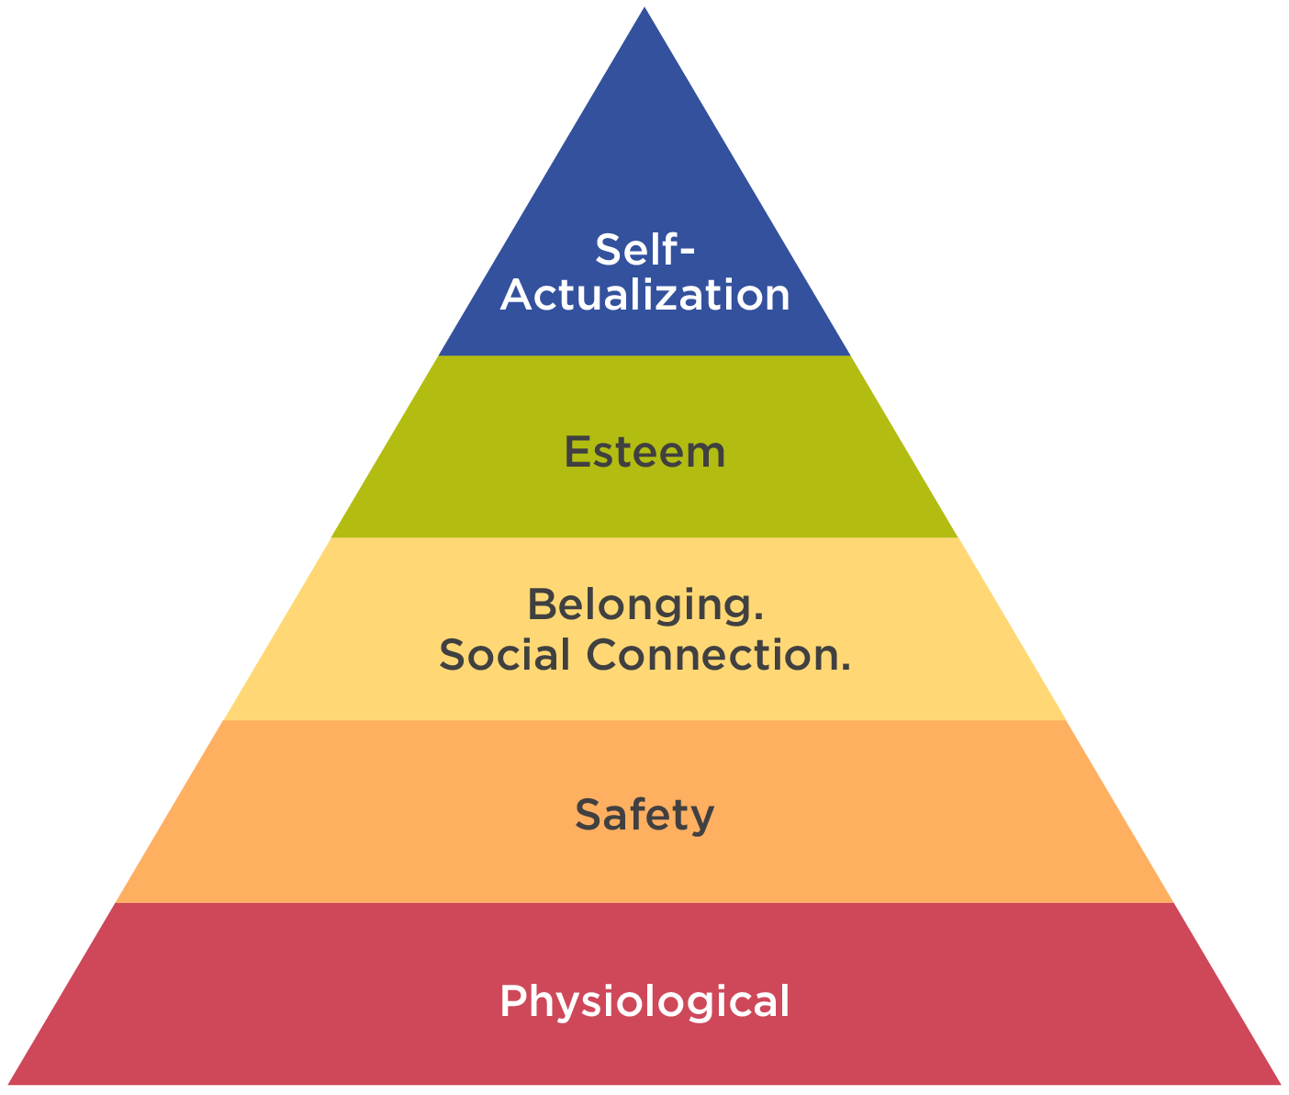

Figure 14.2 illustrates Maslow’s five levels of needs with the most basic at the bottom. Maslow suggested that we need to **meet basic physiological needs (food, water, and air) before we can be motivated to respond to higher-level needs.** Although the hierarchical nature of Maslow’s needs has not been consistently supported by research (we can be motivated by several needs at the same time), his theory provides a useful **checklist of potential listener motivations.** When attempting to persuade an audience, a speaker should try to stimulate these needs in order to change or reinforce attitudes, beliefs, values, or behavior. Let’s examine each of these needs.

**Physiological needs** The most basic needs for all humans are physiological: We all need air, water, and food. According to Maslow’s theory, unless those needs are met, it will be difficult to motivate a listener to satisfy other needs. If your listeners are hot, tired, and thirsty, it will be more difficult to persuade them to vote for your candidate, buy your insurance policy, or sign your petition in support of local leash laws. Be sensitive to the basic physiological needs of your audience so that your appeals to higher-level needs will be heard.

**Safety needs** Listeners are concerned about their safety. We all have a need to feel safe, secure, and protected. We need to be able to predict that our needs for safety, as well as those of our loved ones, will be met. Many insurance sales efforts include photos of wrecked cars, anecdotes of people who were in ill health and could not pay their bills, or tales of the head of a household who passed away, leaving the basic needs of a family unmet. **Appeals to use safety belts, stop smoking, start exercising, and use condoms all play to our need for safety and security.**

**Social needs:** We all need to feel loved and valued. We need contact with others and reassurance that they care about us. According to Maslow, these social needs translate into our need for a sense of belonging to a group (fraternity, religious organization, friendships). **Powerful persuasive appeals are based on our need for social contact.** *We are encouraged to buy a product or support a particular issue because others are buying the product or supporting the issue. The message is that to be liked and respected by others, we must buy the same things they do or support the same causes they support.*

**Self-esteem needs** The need for self-esteem reflects our desire to **think well of ourselves.** Civil rights activist Jesse Jackson is known for appealing to the self-worth of his listeners by inviting them to chant **“I am somebody.”** This is a direct appeal to his listeners’ need for self-esteem. Advertisers also appeal to that need when they **encourage us to believe that we will be noticed by others or stand out in a crowd if we purchase their product.** Commercials promoting luxury cars usually invite you to picture yourself in the driver’s seat with a beautiful or handsome companion beside you while those you pass on the road look on with envy.

**Self-actualization needs** At the top of Maslow’s hierarchy is the need for self-actualization. This is the need to fully realize one’s **highest potential through seeking “peek experiences**.” For many years, the U.S. Army used the slogan “Be all that you can be” to tap into the need for self-actualization. Calls to **be your best and brightest self are appeals to self-actualization**. According to Maslow’s hierarchy, needs at the other four levels must be satisfied before we can be motivated to satisfy the highest-level need

1. **Use positive motivation**

People will be more likely to change their thinking or pursue a particular course of action if t**hey are convinced that good things will happen to them if they support what the speaker advocates.**

e.g. You should take a course in public speaking because it will increase your prospects of getting a good job. Effective communication skills are the most sought-after skills in today’s workplace.

**Emphasize benefits, not Just features**. A benefit is a **good result or something that creates a positive feeling for the listener**. A feature is simply a characteristic of whatever it is that you’re talking about. **A benefit creates a positive emotional sizzle that appeals to the heart. A feature elicits a rational, cognitive reaction; it appeals to the head.** Keep in mind that the heart usually trumps the head when persuading others. Most salespeople know that it is not enough just to identify, in general terms, the features of a product. They must translate those features into an obvious benefit that enhances the customer’s quality of life. **For example, it is not enough for the real-estate salesperson to say, “This floor is the new no-wax vinyl.” It is more effective to add, “And this means that you will never have to get down on your hands and knees to scrub this floor.” When using positive motivational appeals, b**e sure your listeners know how the benefits of your proposal can improve their quality of life or the lives of their loved ones.

1. **Use Negative motivation**

People seek to avoid pain and discomfort. They will be motivated to support what a speaker advocates if they are convinced bad things will happen to them unless they do.

e.g. **If there is a hurricane, tornado, earthquake, or other natural disaster, the electrical power may go out and you may not be able to fill your car with gas. Without the basics of food and water, you could die. You need to be prepared for a worst-case scenario by having an emergency stockpile of water, food, and gas for your car.**

**If you don’t stop that, I’m going to tell Mom!”** Whether he or she realizes it or not, the sibling who threatens to tell Mom is using a persuasive technique called **fear appeal**. **The use of a threat** is one of the oldest methods of trying to change someone’s attitude or behavior, and it is also one of the most effective. In essence, the appeal to fear takes the form of an **“if–then” statement: If you don’t do X, then awful things will happen to you.** A persuader builds an argument on the assertion that a need will not be met unless the desired behavior or attitude change occurs. The principal reason why appeals to fear continue to be made in persuasive messages is that they work. Various research studies support the following principles for using fear appeals.

**A fear appeal directed at audience members themselves is less effective than a strong threat to their loved ones.** A speaker using this principle might say, **“Unless you make sure your children wear safety belts, they could easily be injured or killed in an auto accident.” The more competent, trustworthy, or respected the speaker, the greater the likelihood that an appeal to fear will be successful.** The U.S. Surgeon General will be more successful in convincing people to get a flu shot than you will. A speaker with less credibility will be more successful with moderate threats.

Fear appeals are more successful if you can convince your listeners that **the threat is real and will probably occur unless they take the action you are advocating**. For example, you could dramatically announce, “There is a high probably that pregnant women infected with the Zika virus will have a baby who has a birth defect. To avoid a significant risk to you and your baby, don’t travel to countries with a high Zika infection rate if you are pregnant.”

In general, increasing the intensity of a fear appeal increases the chances that the fear appeal will be effective. This is especially true if the listener can take action (the action the persuader is suggesting) to reduce the threat. **In the past, some researchers and public-speaking texts reported that when a speaker creates an excessive amount of fear and anxiety in listeners, they may consider the appeal too strong, become annoyed, and stop listening. More comprehensive research, however, has concluded that there is a direct link between the intensity or strength of the fear appeal and the likelihood that audience members will be persuaded. Fear appeals work. Strong fear appeals seem to work even better than mild ones, assuming there is evidence to back up the threat made by a credible speaker**. A speaker who uses fear appeals has an **ethical responsibility to b**e truthful and not exaggerate.

Fear appeals are more successful when you can convince your listeners that **they have the power to make a change that will reduce the fear-causing threat**. As a speaker, your goal is not only to **arouse their fear, but also to empower them to act.** When providing a solution to a fear inducing problem, make sure you tell your listeners what they can do to reduce the threat. If, for example, you tell your listeners that unless they lose weight, they will die prematurely. Your audience members may want to shed pounds but think it’s just too hard to do. You’ll be a more effective persuader if you couple your fear-arousing message (lose weight or die early) with a strategy to make weight loss achievable (here’s a diet plan that you can follow; it is simple and it works). The audience-centered principle again applies. You may think the solution is evident, but will your listeners think the same thing? View the solution from your listeners’ point of view.

The effectiveness of a fear appeal is based on the theories of cognitive dissonance and Maslow’s hierarchy of needs. The fear aroused creates dissonance, which can be reduced by following the persuader’s recommendation. Appeals to fear are also based on targeting an unmet need. Fear appeals depend on a convincing insistence that a need will go unmet unless a particular action or attitude change occurs. **Cognitive dissonance, needs, and appeals to the emotions, both positive and negative, can all persuade listeners to change their attitudes, beliefs, values, and behavior**. Realize, however, that persuasion is not as simple as these approaches may lead you to believe. There is no precise formula for motivating and convincing an audience; attitude change occurs differently in each individual. Persuasion is an art that draws on science. Cultivating a sensitivity to listeners’ emotions and needs and ethically using the public-speaking strategies you have learned will help make your persuasive messages effective.

**Questions for Discussion**

Q1: Have you ever be persuaded by someone by using the above persuasion strategy? Be specific.

Q2: Among the above-mentioned persuasion strategies, which one might be effective in your persuasive speech? How are you going to use it?

Q3: Could you give an example of selective exposure and how it might influence your way of accepting the message from a persuasive speaker?

Q4: What are the five levels of needs in Maslow’s classic theory? Could you give a life example to challenge Maslow’s theory?

Q5: If need is the best motivator you might work on to help you persuade your audience, what kind of need would your speech work on?

Q6: What is the difference between persuading people by emphasizing the benefits or the features of using your product or service?

Q7: Do you believe that fear appeals always work in a persuasive speech and strong fear appeals seem to work even better than mild ones. Could you support or refute the above claim with your life experience?

Q8: Why do speakers always recommend a solution if the fear appeal is used to persuade their audience?